**WEST YORKSHIRE FIRE & RESCUE SERVICE**

**JOB DESCRIPTION**

|  |  |
| --- | --- |
| **POST TITLE:** | Watch Manager Operational Policy Operations Hub |
| **GRADE/ROLE:** | Watch Manager |
| **RESPONSIBLE TO:** | Station Manager Operational Policy and Learning |
| **PURPOSE OF POST:** | To build a suite of Operational Guidance, training and risk assessments in line with WYFRS ways of working and National Operational Guidance. This will be hosted in a central location known as the Operations Hub. |

**ORG CHART**

**Operations Support Area Manager**

**Operations Support Group Manager**

**Operational Policy and Learning Station Manager**

**Watch Manager Operational Policy**

**Operations Hub x 3**

**Watch Manager Operational Policy x 2**

**Operational Support**

**MAIN DUTIES AND RESPONSIBILITIES OF THE ROLE**

**Administration:**

1. Identify, research and evaluate operational policies, guidance, and Operational Information Notes (OiN) to facilitate the effective operational response to all incident types.
2. Create new and review existing operational guidance for all incident types.
3. Format current and future documents in line with the accessibility framework.
4. Attend meetings with stakeholders nominated by the Station Manager of Operational Policy and Learning to support the objectives of the department.

**Communication**

1. Liaise with key stakeholders (ops departments, subject matter experts, NFCC, external providers etc.) in the creation and implementation of new guidance.
2. Promote changes and updates of policy, guidance, and operational response to operational personnel via OPIDs (Operations), TPIDs (Training) and support the delivery of content to CPIDs (Control).
3. Use various products (i.e., NFCC Workplace) to share good ideas, offer solutions and seek information from other FRS.
4. Create and deliver training and guidance on how to use the new platform.

**Project Management**

1. Review and assure project deliverables in accordance with KPIs.
2. Undertake appropriate training to use project management and Operation Hub platform tools as requested by the project lead.

**ORGANISATIONAL WIDE RESPONSBILITIES:**

Adherence to the Core Code which sets out five ethical principles, based on the Seven Principles of Public Life.

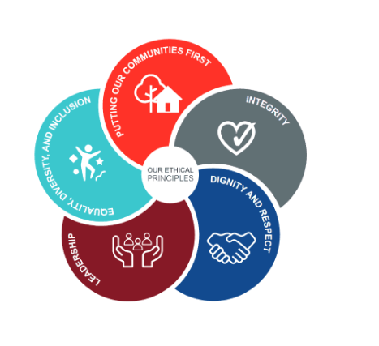

To Implement and promote the Authority’s:

1. Health and Safety policies.
2. Diversity and Inclusion policies.
3. Information Security Management System policies.
4. Safeguarding policies.
5. Business continuity policy and contingency arrangements.
6. Policies related to General Data Protection Regulation and Data Protection Act 2018

(GDPR).

1. Commitment to maintaining our Customer Service expectations.

**SKILLS AND EXPERIENCE REQUIREMENTS FOR THIS ROLE**

**PERSON SPECIFICATION**

|  |  |  |  |
| --- | --- | --- | --- |
|  | **Experience** | **Essential/ Desirable** | **Source** |
| 1 | Possess practical experience of emergency operations in a wide variety of scenarios. | Essential | Application & Selection Process |
| 2 | Possess consistent effective operational command experience | Desirable | Applications & Selection Process |
| 3 | Demonstrates political awareness and able to maintain confidentiality when dealing with sensitive information. | Essential | Selection Process |
| 4 | Experience of influencing and supporting others effectively in a large multicultural organisation. | Essential | Selection Process |
| 5 | Experience in working effectively with external partners | Desirable | Application & Selection Process |
| 6 | Experience of organising and delivering off station training | Essential | Application & Selection Process |

|  |  |  |  |
| --- | --- | --- | --- |
|  | **Education and Training** | **Essential/ Desirable** | **Source** |
| 7 | Achieved the required fitness levels to meet operational requirements | Essential | Application |
| 8 | IOSH Working Safely | Essential | Application |
| 9 | Have a recognised qualification in leadership and management. | Desirable | Application |
| 10 | Passed the Skills for Justice Initial incident Command assessment | Desirable | Application |
| 11 | Possess or be working towards IFE level 3 Diploma. | Desirable | Application |

|  |  |  |  |
| --- | --- | --- | --- |
|  | **Special Knowledge and Skills** | **Essential/ Desirable** | **Source** |
| 12 | Planning, analytical, numerical and problem-solving skills. | Essential | Application & Selection Process |
| 13 | Good organisational skills including the ability to deal with conflicting demands to meet deadlines. | Essential | Application & Selection Process |
| 14 | Ability to work with others by recognising and acting upon the needs of team members. | Essential | Application & Selection Process |
| 15 | Demonstrate a proactive, confident, and resilient approach. | Essential | Application & Selection Process |
| 16 | High level of written and verbal communication skills. | Essential | Application & Selection Process |
| 17 | Demonstrate an understanding of the importance of diversity and inclusion to WYFRS as an employer and service provider | Essential | Selection Process |
| 18 | Demonstrate an understanding of and ability to implement Health & Safety in the workplace. | Essential | Application & Selection Process |
| 19 | Familiarity with a wide range of Microsoft products including Word, Excel, PowerPoint, and Teams. | Essential | Application & Selection Process |

**Job Description: Last updated: June 2024**